PROJECT SYNOPSIS
“ Softpro Analytics”
SYNOPSIS SUBMITTED IN PARTIAL FULFILMENT OF THE REQUIREMENTS
FOR THE AWARD OF THE DEGREE OF BACHELOR OF TECHNOLOGY (B.TECH)
IN ARTIFICIAL INTELLIGENCE & DATA SCIENCE
SUBMITTED TO
Dr APJ Abdul kalam Technical University Lucknow
Future Institute of Engineering & Technology, Bareilly
SUBMITTED BY:
Ramesh Kumar
(College Roll Number - 2204761630024 )
(College Enrolment Number - 220476163069887 )
2022-2026



Under the Guidance of
Er. Awnish Kr Sharma
Senior Consultant
SOFTPRO INDIA COMPUTER TECHNOLOGIES (P) LTD

Preface
This project report entitled “Softpro Analytics – Sentiment & Sales Insights” is submitted in partial fulfillment of the requirements for the degree of B.Tech in Artificial Intelligence & Data Science

The project has been designed and implemented with the objective of developing a web-based AI-powered system that integrates audio call transcripts with CRM logs to generate actionable insights for counseling and management. By applying speech-to-text transcription, sentiment analysis, and data visualization techniques, this project provides a centralized platform for improving student engagement and conversion.
The report presents a complete overview of the project, including system design, tools and technologies used, implementation details, testing, challenges faced, and future scope.
I sincerely hope that this project will serve as a valuable contribution to both academic learning and practical applications in the field of Artificial Intelligence and Data Analytics.

Acknowledgement
I express my deepest gratitude to Dr APJ Abdul Kalam Technical University Lucknow for providing me with the opportunity to undertake this project as part of my academic curriculum.
I would like to sincerely thank my guide, Er. Awnish Kr Sharma, Senior Consultant, Softpro India Computer Technologies (P) Ltd, for his continuous support, valuable guidance, and encouragement throughout the course of this project. His expertise and mentorship have been instrumental in the successful completion of this work.
I also extend my heartfelt appreciation to the faculty members of the Department of Computer Applications for their support and insightful suggestions.
Finally, I would like to acknowledge the support and cooperation of my friends, peers, and family members, who motivated me at every step during the development of this project.

Certificate of Completion
Dr. A.P.J. Abdul Kalam Technical University (AKTU), Lucknow
Future Institute of Engineering & Technology, Bareilly
This is to certify that the project report entitled
“Softpro Analytics – Sentiment & Sales Insights”
has been successfully completed and submitted by:
( RAMESH KUMAR )
Batch: 2022 – 2026
(College Roll Number - 2204761630024 )
(College Enrolment Number - 220476163069887 )

under the supervision of
Er. Awnish Kr Sharma
Senior Consultant,
Softpro India Computer Technologies (P) Ltd.
in partial fulfillment of the requirement for the award of the degree of
B.Tech in Artificial Intelligence & Data Science
From Dr. A.P.J. Abdul Kalam Technical University (AKTU), Lucknow
Date: 30/8/2025
Place: Lucknow
Signature of Guide
(Er. Awnish Kr Sharma)
Head of Department
( Artificial Intelligence & Data Science )
)
Seal/Stamp of University

About Company
Softpro India Computer Technologies (P) Ltd., established in 2004, is one of the leading IT and training companies based in Lucknow, Uttar Pradesh. The company specializes in Software Development, IT Training, Industrial Training, Corporate Training, and Consultancy Services.
Over the years, Softpro India has trained thousands of engineering and computer application students, equipping them with industry-ready technical skills. It also provides customized software solutions to corporate clients in sectors like education, healthcare, finance, and government.
Key Highlights:
- Expertise in Python, Java, MERN, AI/ML, Data Analytics, and Cloud Technologies.
- Provides 6 Weeks / 6 Months Industrial Training for B.Tech, BCA, MCA, and MBA students.
- Offers corporate training programs to bridge the gap between academics and industry needs.
- Runs live projects for students to gain hands-on practical exposure.
The company’s mission is to empower students and professionals with the latest IT skills, ensuring they remain competitive in today’s technology-driven world.
Website: www.softproindia.in

Softpro Analytics – Sentiment & Sales Insights

Introduction
In today’s competitive academic environment, institutions rely heavily on effective student counseling to improve admissions, retention, and overall student satisfaction. A significant portion of this counseling is conducted through audio interactions between students and counselors, where valuable insights such as student concerns, objections, interests, and sentiments are often hidden within the conversation. Traditionally, analyzing these interactions has been a manual, time-consuming process, leading to missed opportunities and limited scalability.
To overcome these challenges, Softpro Analytics has been developed as a web-based AI-powered system that integrates audio call transcripts with CRM logs to provide a data-driven decision-making platform. The system leverages speech-to-text transcription, Natural Language Processing (NLP), and sentiment analysis to convert unstructured data into actionable insights.
The project aims to empower counselors, trainers, and management staff with a centralized, interactive dashboard that not only visualizes student sentiment but also generates recommendations for improving conversion rates and addressing student concerns more effectively.

Key Objectives of the System:
- Automation of Analysis – Eliminate manual effort by automatically transcribing counselor-student calls into structured text.
- Sentiment Detection – Classify conversations into positive, negative, or neutral categories to gauge overall student satisfaction.
- Integration with CRM Logs – Merge transcripts with student data (name, year, tech stack, location, etc.) for contextual analysis.
- Visual Dashboards – Provide counselors and management with interactive charts, word clouds, and trend analysis.
- Recommendations Engine – Suggest actionable steps to counselors based on frequent objections (e.g., fees, timing, placement) and sentiment patterns.
- Improved Decision-Making – Assist management in identifying trends, tracking performance, and implementing data-driven strategies.

Problem Statement
The current counseling process faces major challenges:
- Manual analysis of student calls is slow and error-prone.
- There is no central platform that combines CRM logs and audio insights.
- Counselors lack data-driven recommendations, relying mostly on intuition.
- Negative feedback often goes unnoticed due to absence of automated sentiment tracking.

Proposed Solution
The Softpro Analytics System addresses these issues by automating the entire pipeline:
Audio → Text → Sentiment → Insights → Recommendations.
This ensures that every student interaction is captured, analyzed, and utilized to improve counseling effectiveness, enhance training strategies, and boost conversion rates. The design is modular and scalable, ensuring adaptability to future enhancements such as multilingual support, real-time CRM integration, and voice emotion detection.

About Project
The Softpro Analytics System is a web-based platform designed to revolutionize the way student-counselor interactions are analyzed and utilized for decision-making. It integrates automatic speech recognition (ASR), natural language processing (NLP), sentiment analysis, and data visualization into a single streamlined pipeline. The goal of the project is to enable counselors, trainers, and management staff to make informed, data-driven decisions that enhance student engagement and improve conversion rates.

Project Overview
- Name of the Project: Softpro Analytics – Sentiment & Sales Insights
- Domain: Artificial Intelligence, Natural Language Processing, Data Analytics
- Technology Stack: Python, Streamlit, Whisper/Vosk, Transformers, Plotly
- Target Users: Counselors, Trainers, and Management Staff at Softpro Institute
- Duration: 2–3 months for prototype, with scope for long-term scalability

Project Workflow
The system automates the entire process from data acquisition to insight generation:
- Data Collection
  - Audio recordings of student-counselor calls in MP3/WAV format.
  - Student information logs stored in CSV format (name, year, tech stack, location, remarks, etc.).
- Data Processing
  - Audio files are transcribed into text using Whisper (cloud-based) or Vosk (offline) models.
  - Student transcripts are merged with CRM logs for context.
- Sentiment Analysis
  - Sentiment is predicted using pretrained Hugging Face models or custom-trained models using TF-IDF + Logistic Regression.
  - Each transcript is classified into positive, negative, or neutral categories with associated confidence scores.
- Analytics & Visualization
  - Sentiment distribution is visualized using pie charts, bar graphs, and line charts.
  - Negative keywords are extracted using TF-IDF and displayed as word clouds.
  - Counselors can filter results by location, tech stack, or time range.
- Recommendation Generation
  - A rule-based engine detects recurring student concerns (e.g., fees, timing, placement).
  - Generates personalized recommendations such as offering evening batches, providing installment fee options, or highlighting placement records.
- Output & Reporting
  - Interactive dashboard (Streamlit-based) for real-time insights.
  - Exportable reports (CSV/PDF) for management review and record-keeping.

Project Implementation
The project follows the Software Development Life Cycle (SDLC), covering:
- Requirement Analysis: Understanding counselor needs, CRM structure, and call data.
- Design: Modular, layered architecture ensuring scalability and flexibility.
- Coding: Implementation in Python using libraries like pandas, transformers, whisper, and plotly.
- Testing: Unit, integration, system, and user acceptance testing to ensure reliability.
- Deployment: Streamlit app deployed locally or on intranet for easy access.

Project Goals
- Automation: Reduce manual effort in analyzing counselor-student calls.
- Actionable Insights: Provide meaningful recommendations to improve student conversion.
- Scalability: Handle 1000+ students and multiple audio files simultaneously.
- Cost-Effectiveness: Implemented entirely with open-source tools, ensuring zero licensing cost.
- Usability: Designed for non-technical users, requiring minimal training.

Key Modules in the Project
- Student Management – Manage student profiles and logs.
- Audio Upload & Transcription – Convert counselor-student calls into text.
- CRM Log Integration – Merge call transcripts with student interaction logs.
- Sentiment Analysis Engine – Predict and classify feedback.
- Analytics Dashboard – Visualize data using interactive charts and word clouds.
- Recommendations Engine – Generate counselor tips based on student feedback.
- Export Reports – Allow users to download insights for further use.
- User Authentication (Optional) – Ensure secure access to data and dashboards

Hardware Requirements (Updated for Heavy Models)

Minimum (For Prototype / Small-Scale Use)
- Processor: Intel i5 (10th Gen or above) / AMD Ryzen 5 equivalent
- RAM: 8 GB
- Storage: 256 GB SSD (for faster read/write of audio and transcripts)
- Graphics: Integrated graphics (processing will be slower, but feasible)
- Operating System: Windows 10/11 or Linux Ubuntu 20.04+

Recommended (For Smooth Execution of Heavy Models)
- Processor: Intel i7 (11th Gen or above) / AMD Ryzen 7 equivalent
- RAM: 16 GB or higher (for running Whisper + Transformers in memory)
- Storage: 512 GB SSD (models + transcripts + CRM logs)
- Graphics (GPU):
  - NVIDIA GTX 1660 / RTX 2060 or higher (CUDA-enabled for GPU acceleration)
  - At least 6 GB VRAM for Whisper Large or BERT-like models
- Operating System: Linux Ubuntu 22.04 LTS (preferred for ML environments)

Advanced / Scalable Setup (For Enterprise or Large Dataset Training)
- Processor: Intel i9 / AMD Ryzen 9 or Threadripper series
- RAM: 32 GB – 64 GB (for parallel transcription and training custom sentiment models)
- Storage: 1 TB NVMe SSD (fast disk I/O for handling large audio datasets)
- Graphics (GPU):
  - NVIDIA RTX 3080 / A100 / Tesla V100 with 16–40 GB VRAM
  - Required for batch processing of 1000+ audio files and training large NLP models efficiently
- Deployment Option:
  - On-Premise High-Performance Server OR
  - Cloud Platforms (AWS/GCP/Azure) with GPU instances (e.g., NVIDIA A100, T4, or V100)

Software Requirements
The Softpro Analytics System is developed and deployed using open-source tools and modern frameworks. Below are the software requirements for different setups:

1. Operating System
- Minimum: Windows 10 / Linux Ubuntu 20.04
- Recommended: Windows 11 Pro / Linux Ubuntu 22.04 LTS (preferred for AI & ML model compatibility)

2. Programming Language
- Python 3.10+ – Core programming language for implementation

3. Development Environment
- IDE: Visual Studio Code / PyCharm (for coding and debugging)
- Jupyter Notebook (Optional): For testing ML models and data preprocessing

4. Libraries & Frameworks
- Data Processing:
  - pandas, numpy (for handling CSV logs, preprocessing)
- Machine Learning / NLP:
  - scikit-learn (for Logistic Regression, TF-IDF vectorization)
  - transformers (Hugging Face) – for pretrained sentiment models like BERT, RoBERTa
  - whisper (OpenAI) – for speech-to-text transcription
  - vosk (Offline ASR alternative) – for low-resource environments
- Visualization:
  - plotly – for interactive charts and graphs
  - matplotlib / seaborn (optional) – for static plots
- UI / Dashboard:
  - streamlit – for web-based dashboard development
- Database (Optional):
  - SQLite / MySQL – for storing logs, transcripts, and sentiment outputs

5. Deployment Environment
- Local Deployment:
  - Streamlit app hosted on local machine or internal intranet
- Cloud Deployment (Optional for Scaling):
  - AWS (EC2 with GPU, S3 for storage)
  - Google Cloud Platform (Vertex AI, GPU instances)
  - Microsoft Azure (VM with CUDA support)

6. Version Control
- Git & GitHub/GitLab – for source code management and collaboration

7. Additional Tools
- Browser: Chrome / Firefox (to access the dashboard)
- Package Management: pip / conda (for installing dependencies)
- Virtual Environment: venv or Anaconda (to isolate project dependencies)

Tools Used for Implementation
The Softpro Analytics system is implemented using modern, open-source tools to ensure flexibility, cost-effectiveness, and scalability.

1. Programming Language
- Python – Core programming language for data processing, model integration, and application logic.

2. Frontend / User Interface
- Streamlit – Used for building the interactive dashboard and user interface for uploading data, viewing analytics, and displaying recommendations.

3. Libraries and Frameworks
- pandas, numpy – For data preprocessing, cleaning, and efficient handling of CSV logs.
- scikit-learn – For machine learning tasks such as training Logistic Regression sentiment models and TF-IDF vectorization.
- transformers (Hugging Face) – For leveraging pretrained sentiment analysis models.
- whisper (OpenAI) / vosk – For automatic speech recognition (transcription of audio calls into text).
- plotly – For visualization of insights via interactive charts and graphs.

4. Database (Optional)
- SQLite / MySQL – For storing student logs, transcripts, and analysis results if persistent storage is required.

5. Development Environment
- VS Code / PyCharm – IDEs used for development and debugging.
- Python 3.10+ – Required runtime environment.

6. Deployment
- Local Server / Intranet – Streamlit app deployed internally for counselors and management to access securely.

Design Analysis

High Level Designing
Level-0 DFD: Student → Counselor Call → Softpro Analytics → Insights
Level-1 DFD: Audio Upload → Transcription → Sentiment → Analytics → Recommendations
ER Diagram: Entities – Student, Call, Transcript, Sentiment, Recommendation

Low Level Designing
Database Tables:
Students: StudentID, Name, Year, TechStack, Location
Calls: CallID, StudentID, Date, Remarks
Transcripts: TranscriptID, CallID, Text
Sentiment: SentimentID, TranscriptID, SentimentLabel, SentimentScore

Modules in Project
• Student Management
• Audio Upload & Transcription
• CRM Log Integration
• Sentiment Analysis Engine
• Analytics Dashboard (Charts, Wordcloud)
• Recommendations Engine
• User Authentication (optional)
• Export Reports

Module Description
1. Student Management – Manage student profiles & logs
2. Audio Upload – Convert audio to text
3. Sentiment Analysis – Predict positive/negative feedback
4. Analytics Dashboard – Visualize insights with charts
5. Recommendations – Generate counselor tips (fees, timing, placement, etc.)

Design Diagrams

Level-0 DFD
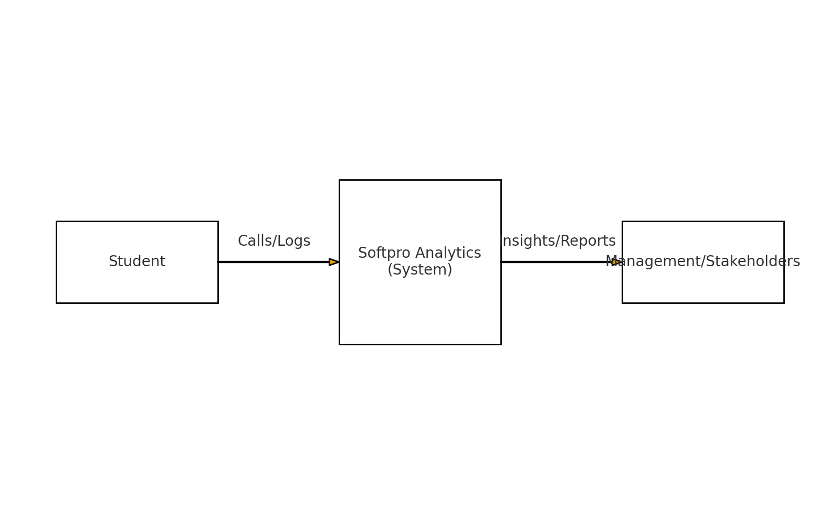

Level-1 DFD
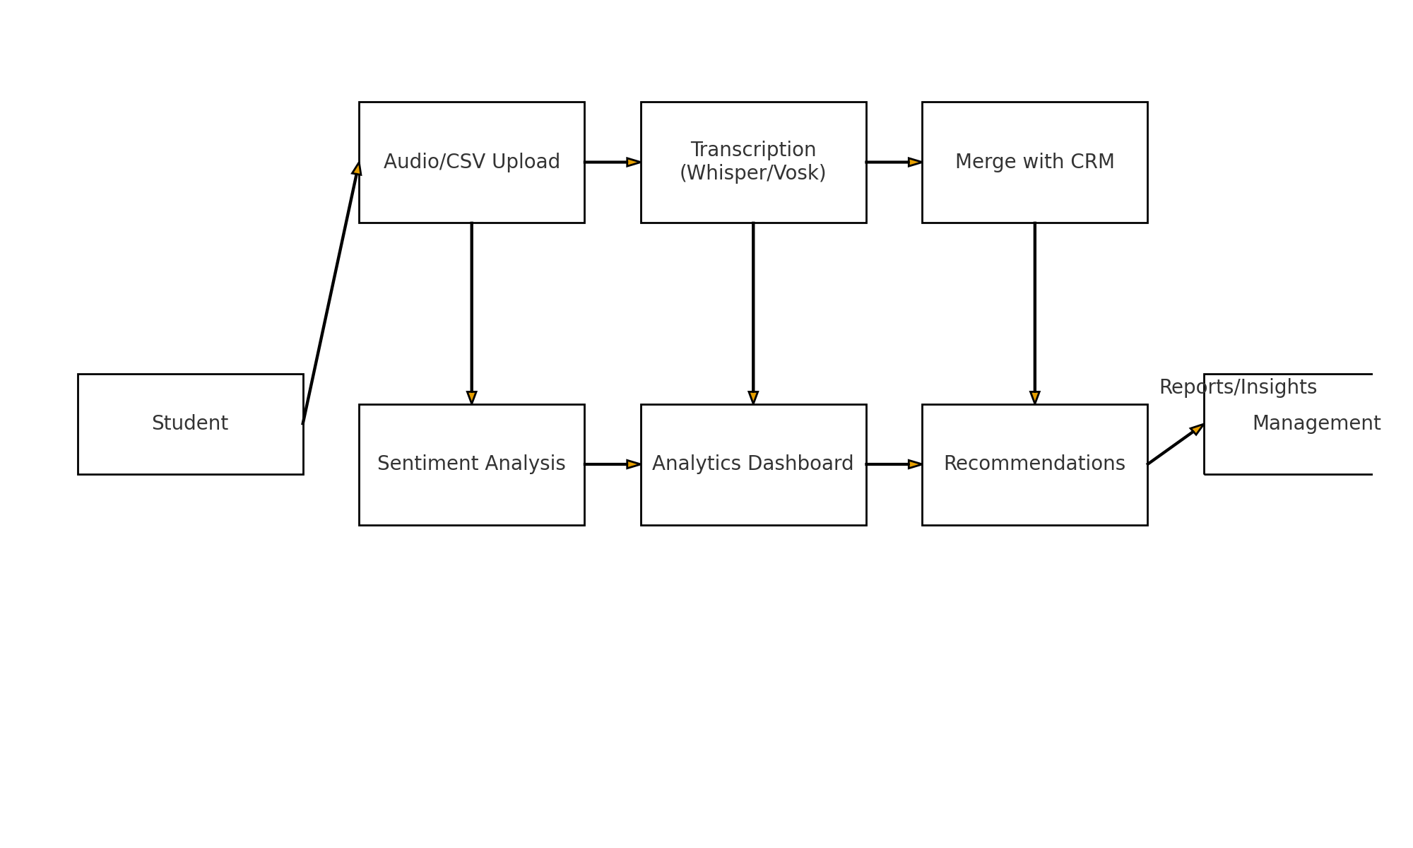

ER Diagram
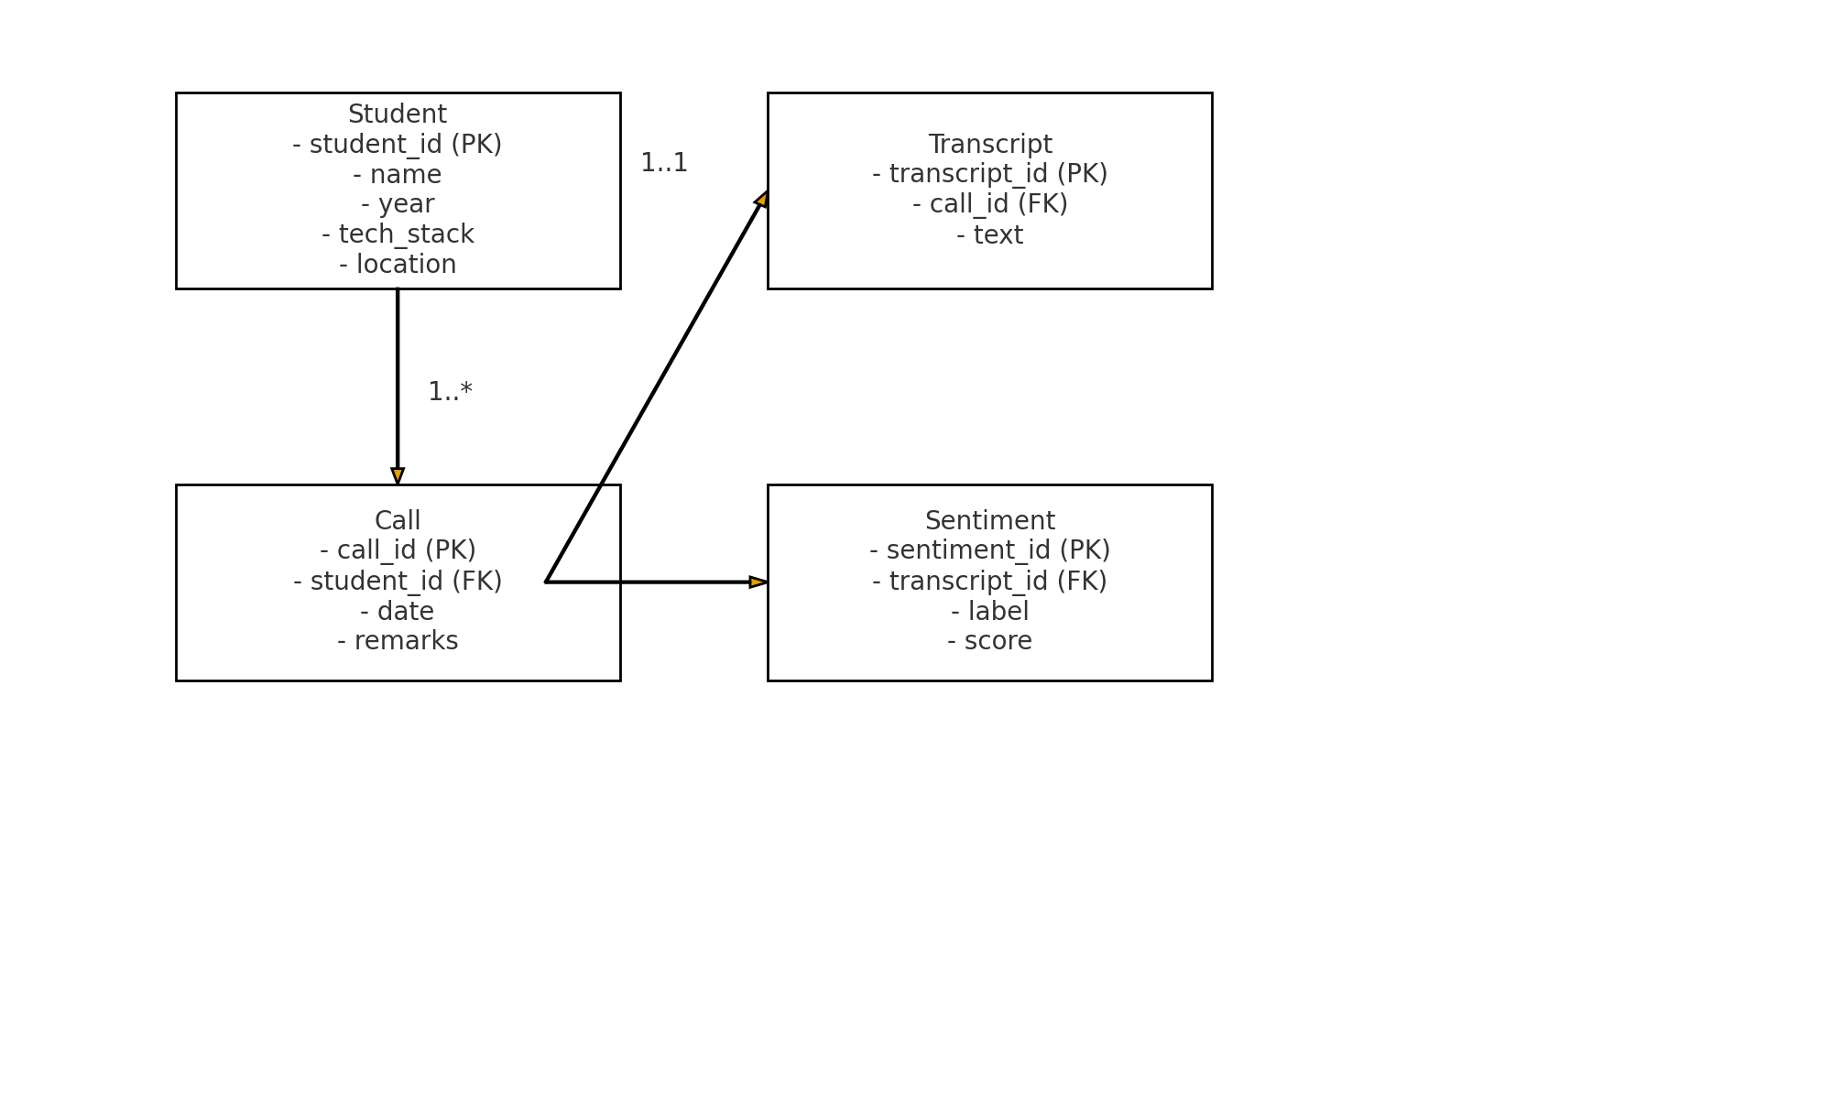

System Design

Design
The design of the Softpro Analytics system follows a modular and layered approach to ensure scalability, maintainability, and clarity.
- Input Layer: Handles uploading of audio recordings and CSV student logs.
- Processing Layer: Includes transcription (Whisper/Vosk), sentiment analysis (custom model or pretrained pipeline), and data merging logic.
- Analysis Layer: Applies Natural Language Processing (NLP) techniques like TF-IDF vectorization, classification, and keyword extraction.
- Visualization Layer: Provides interactive dashboards using Streamlit and Plotly for real-time insights.
- Recommendation Engine: Uses rule-based heuristics to suggest improvements in training, counseling, and sales approaches.
This layered design ensures that each module is testable and interchangeable. For example, Whisper can be replaced with Vosk for offline transcription without changing the rest of the pipeline.

User Characteristics
The primary users of Softpro Analytics are counselors, trainers, and management staff at Softpro Institute. Their characteristics include:
- Counselors: Non-technical background; require an easy-to-use dashboard to upload recordings and logs, then view recommendations.
- Trainers: Interested in understanding student concerns related to specific technology stacks (Python, Java, MERN, AI/ML).
- Management: Needs high-level insights such as overall sentiment trends, location-wise performance (Noida vs. Lucknow), and sales-related objections.
- Students (Indirect Users): Although not direct users of the system, their feedback and call logs drive the analytics process.
The interface is designed to be minimal and intuitive, requiring little to no technical expertise.

System Information
The system integrates multiple components:
- Data Sources:
  - Audio recordings of counselor-student interactions (.mp3/.wav).
  - Student interaction logs in CSV format (with student details, remarks, call IDs, etc.).
- Processing Tools:
  - Whisper (OpenAI) for transcription.
  - Vosk (offline ASR) as an alternative.
  - Hugging Face Transformers for pretrained sentiment analysis.
  - Scikit-learn for custom TF-IDF + Logistic Regression sentiment classification.
- Frontend:
  - Streamlit-based dashboard for data upload, visualization, and recommendation display.
- Storage:
  - Temporary storage of processed CSVs and transcripts.
  - Final merged dataset exportable as .csv for record-keeping.
- Deployment Environment:
  - Python 3.10+
  - Streamlit app deployed on local server or internal intranet.

System Analysis
The analysis of Softpro Analytics covers functional and non-functional requirements:
- Functional Requirements:
  - Upload and parse CSV logs.
  - Transcribe audio recordings to text.
  - Merge transcripts with student interaction logs.
  - Perform sentiment analysis (pretrained/custom).
  - Generate insights and recommendations.
- Non-functional Requirements:
  - Usability: Simple UI for counselors.
  - Scalability: Handle 1000+ students and multiple audio files.
  - Accuracy: Ensure transcription and sentiment outputs are reliable.
  - Performance: Process within reasonable time (<1 min for small datasets).
The system analysis confirms feasibility for both short-term pilot use and long-term scaling.

Feasibility Analysis
Feasibility is analyzed across different dimensions:
- Technical Feasibility:
  - Open-source tools like Whisper, Vosk, and Transformers are readily available.
  - Python and Streamlit are well-suited for rapid development.
- Economic Feasibility:
  - No licensing costs (open-source libraries).
  - Hardware requirements limited to a mid-range PC with sufficient RAM/CPU.
- Operational Feasibility:
  - Easy to train staff in uploading CSVs and recordings.
  - Recommendations are actionable and directly improve counseling processes.
- Schedule Feasibility:
  - Prototype can be developed within 2–3 months.
  - Additional improvements like predictive modeling can be added later.
Thus, the project is feasible and cost-effective for Softpro Institute.

Context Design
The Context Design illustrates how different entities interact with the system.
- Actors:
  - Counselor (uploads CSV, audio files).
  - Student (provides feedback via calls/logs).
  - Management (reviews insights).
- Processes:
  - Counselor uploads call logs and recordings.
  - System transcribes and merges audio with logs.
  - Sentiment analysis is applied.
  - Dashboards and recommendations are generated.
- Outputs:
  - Insights by location, tech stack, and sentiment.
  - Recommendations for improving conversion and reducing negativity.
  - Exportable reports for internal use.
In diagrammatic terms, the Context Diagram will show:
- External entities (Counselors, Management, Students).
- Central system (Softpro Analytics).
- Inputs (Audio, CSV logs) and Outputs (Insights, Reports).

Dashboard Design
The Softpro Analytics Dashboard is the central interface where counselors, trainers, and management staff interact with the system. It transforms raw transcripts, CRM logs, and sentiment outputs into clear, visual insights. The design ensures a minimal, intuitive layout that requires no technical expertise, making it accessible for all user groups.

Key Components of the Dashboard
- Data Upload Panel
  - Allows users to upload audio recordings (MP3/WAV) and CSV CRM logs.
  - Displays status of uploads with error-handling messages for invalid or missing files.
- Transcription & Sentiment Section
  - Shows automatically generated transcripts of uploaded audio.
  - Displays sentiment distribution (Positive, Negative, Neutral) along with confidence scores.
- Visual Analytics
  - Pie Charts: Sentiment distribution across all calls.
  - Bar Charts: Location-wise and technology stack–wise sentiment comparisons.
  - Line Charts: Monthly sentiment trends for tracking progress over time.
  - Wordclouds: Frequently used negative/positive keywords extracted via TF-IDF.
- Filtering & Drill-Down Options
  - Filters by location (Lucknow, Noida, etc.), tech stack (Python, Java, MERN, AI/ML), and time range.
  - Enables counselors to focus on subsets of data for targeted analysis.
- Recommendations Panel
  - AI-powered suggestions generated based on sentiment patterns and keyword detection (e.g., objections about fees, timing, placement).
  - Provides actionable counselor tips such as “Offer evening batches”, “Highlight placement success stories”, or “Adjust fee installment plans”.
- Export & Reporting
  - Generates downloadable CSV/PDF reports with merged transcripts, sentiment scores, and insights.
  - Useful for management reviews and long-term tracking.

Benefits of the Dashboard
- Replaces manual analysis with an automated, visual, and interactive system.
- Helps counselors by providing real-time insights into student concerns.
- Assists trainers in understanding technology-related issues raised by students.
- Equips management with high-level overviews of performance trends, objections, and opportunities to improve conversions.

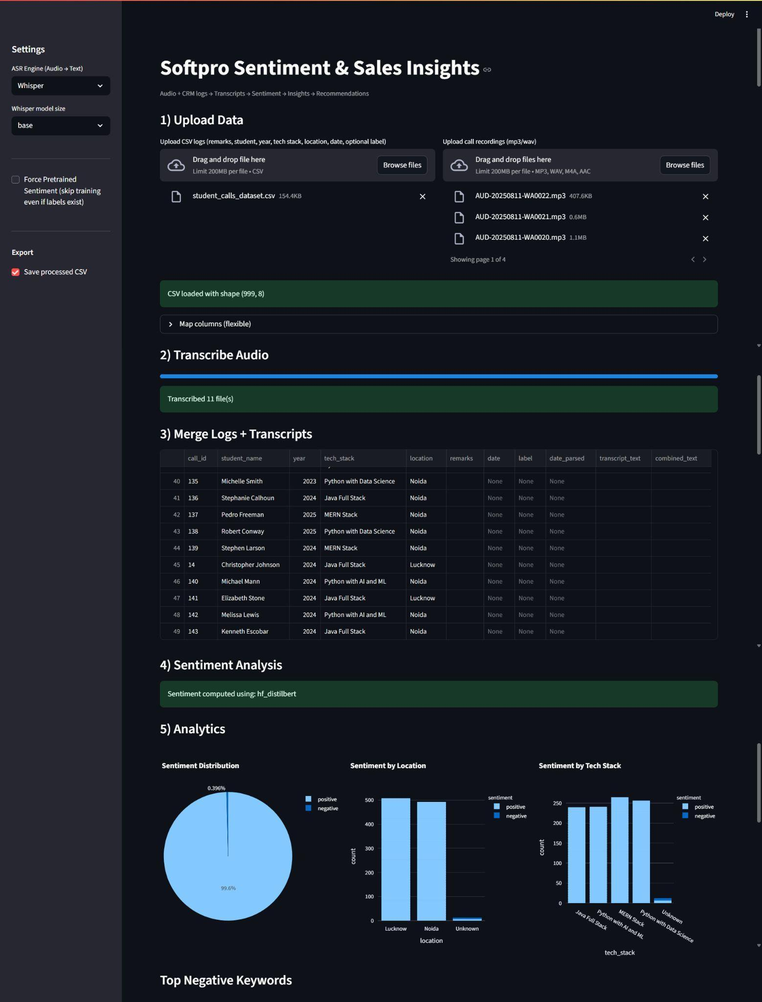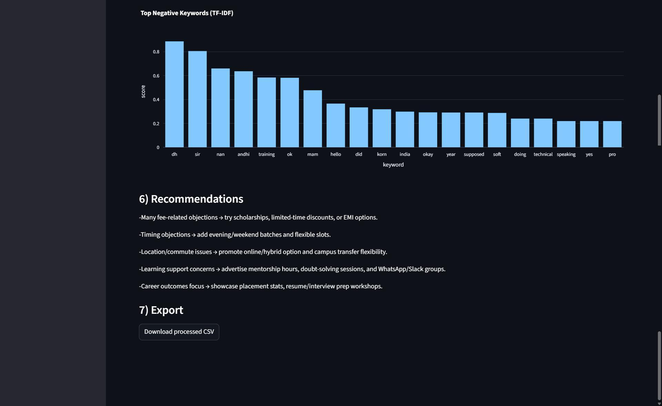

Software Testing

Why Software Testing is Needed
Software testing is an essential activity in the Software Development Life Cycle (SDLC).
- It ensures the correctness, completeness, and quality of the developed system.
- In the Softpro Analytics project, testing validates whether transcription, sentiment analysis, and dashboards work as intended.
- Testing helps to:
  - Detect defects early in development.
  - Ensure the software meets functional and non-functional requirements.
  - Improve reliability and user satisfaction.
  - Reduce maintenance costs after deployment.

Testing Strategy
For the Softpro Analytics system, a hybrid testing strategy is applied:
- Unit Testing → To test individual modules (e.g., transcription function, CSV upload handler).
- Integration Testing → To check interactions between audio-to-text, sentiment analysis, and visualization modules.
- System Testing → To validate the complete Streamlit app in a real-world scenario.
- User Acceptance Testing (UAT) → Conducted with Softpro’s counselors and management to ensure usability and business requirements are met.
The testing strategy follows an incremental approach, where modules are tested in isolation first, then integrated step by step.

White Box Testing
White box testing focuses on the internal logic and code structure.
- Applied during unit testing of Python functions like transcribe_with_whisper() and gen_recos().
- Techniques used:
  - Statement coverage – ensuring every line of code is executed at least once.
  - Branch coverage – verifying all decision branches (e.g., sentiment positive/negative paths) are tested.
  - Path coverage – testing all logical paths in functions such as data merging and CSV handling.
In this project, white box testing ensures correctness of algorithms (e.g., TF-IDF vectorizer training and sentiment classification).

Black Box Testing
Black box testing validates the system without knowing internal code, focusing on inputs and outputs.
- Example test cases:
  - Upload valid/invalid CSV files and check error handling.
  - Upload MP3/WAV audio and ensure correct transcription.
  - Input empty remarks and check if defaults are handled.
  - Analyze data with and without sentiment labels and verify consistent outputs.
- Ensures the app works for real users under different scenarios.
Black box testing was especially useful during UAT, where end-users validated whether the dashboard produced meaningful insights and recommendations.

How Testing Was Utilized in Softpro Analytics
Testing in Softpro Analytics was not only theoretical but actively implemented in the development process. The following points describe its utilization in detail:
- Audio Transcription Validation
  - Uploaded multiple MP3/WAV recordings to ensure Whisper correctly converted speech to text.
  - Tested with background noise, low volume, and different accents to evaluate robustness.
  - Verified transcripts matched manual transcriptions within acceptable accuracy.
- CSV Upload & Data Handling
  - Tested CSVs with missing values, incorrect date formats, and extra columns.
  - Validated that the app handled errors gracefully (e.g., filling missing remarks with “”).
  - Ensured merging of CSV logs and transcripts worked with both call_id and index-based joins.
- Sentiment Analysis Output
  - Cross-checked pretrained Hugging Face sentiment model results with manually labeled remarks.
  - For training mode, tested Logistic Regression with small labeled datasets and validated accuracy reports.
  - Verified correct mapping of positive/negative labels even if user provided abbreviations like P/N.
- Analytics Dashboards
  - Checked pie chart distribution of sentiments matched expected proportions from test data.
  - Tested filtering by Location (Noida/Lucknow) and Tech Stack to confirm correct grouping.
  - Verified monthly trend line plotted data in chronological order even with mixed date formats.
- Recommendations Engine (gen_recos)
  - Validated rule-based conditions (e.g., negative >40% triggers recommendations).
  - Tested keyword detection for objections like fees, timing, placement by injecting them in sample data.
  - Confirmed that suggestions changed dynamically depending on sentiment ratios and keywords.
- User Acceptance Testing (UAT)
  - Conducted trials with Softpro counselors who uploaded their own logs and recordings.
  - Gathered feedback on whether insights were meaningful and improved the UI accordingly.
  - Adjusted recommendations to make them more practical (e.g., “offer evening batches” when timing issues were frequent).
- Performance Testing
  - Uploaded 1000+ student records to ensure the app handled large datasets without crashing.
  - Verified transcription of multiple audio files in batch mode completed within reasonable time.

Conclusion
The Softpro Analytics project successfully demonstrates how AI-driven tools can transform raw student-counselor interactions into actionable insights. By integrating speech-to-text transcription, sentiment analysis, and CRM data, the system provides:
- A centralized, automated dashboard that reduces manual analysis effort.
- Actionable recommendations to counselors and management for improving student conversions.
- A scalable and cost-effective solution that can handle large datasets with high accuracy.
The layered, modular design ensures maintainability and adaptability. For example, the transcription engine can switch between Whisper and Vosk without affecting the rest of the pipeline. With its focus on usability, the system is accessible to non-technical counselors while still offering deep analytical insights for management.
In essence, Softpro Analytics bridges the gap between raw student feedback and data-driven decision-making, ensuring better counseling outcomes and improved business performance.

Future Scope
The project provides a strong foundation but also has scope for advanced features and enhancements in future versions:
- Multilingual Support
  - Extend transcription and sentiment models to support Hindi, Hinglish, and regional languages for wider applicability.
- Real-Time CRM Integration
  - Direct integration with CRM APIs to fetch logs automatically instead of manual CSV uploads.
- Voice Emotion Detection
  - Detect emotions like anger, hesitation, or excitement directly from voice tone, complementing text-based sentiment.
- Mobile-Friendly Version
  - A lightweight, responsive mobile app/dashboard for on-the-go counselors and management staff.
- AI-Driven Personalized Scripts
  - Generate counselor scripts dynamically based on student sentiment, objections, and past interactions for more personalized conversations.
- Scalability Enhancements
  - Move towards cloud deployment for real-time performance monitoring across thousands of student interactions simultaneously.

Challenges
While developing Softpro Analytics – Sentiment & Sales Insights, several challenges were encountered at different stages of the Software Development Life Cycle (SDLC). These challenges are both technical and operational in nature:

1. Speech-to-Text Accuracy
- Problem: Transcribing audio files into text with high accuracy was difficult due to background noise, varying student accents, and low-quality recordings.
- Solution: Used Whisper (cloud-based) for better accuracy and Vosk (offline) as a backup. Multiple samples were tested under noisy environments to fine-tune model reliability.

2. Handling Large Data Volumes
- Problem: Processing 1000+ student logs and multiple audio files at once slowed down performance.
- Solution: Implemented batch processing and optimized data handling using pandas and numpy. Recommended higher hardware/GPU resources for scaling.

3. Sentiment Classification Limitations
- Problem: Pretrained sentiment models sometimes failed to capture context-specific words like fees, timing, or placement objections.
- Solution: Added a custom TF-IDF + Logistic Regression model trained on domain-specific student counseling data. Also integrated keyword extraction for better accuracy.

4. Integration of Transcripts with CRM Logs
- Problem: Mismatched keys (call IDs, student names) caused merging errors between transcripts and CSV logs.
- Solution: Implemented flexible matching strategies (index-based + call_id based joins) and added error-handling for missing or inconsistent data.

5. Dashboard Usability for Non-Technical Users
- Problem: Counselors and trainers, who are non-technical users, needed a simple, intuitive interface.
- Solution: Built the UI using Streamlit, which allowed drag-and-drop uploads, easy filtering, and real-time visualization without complex navigation.

6. Realistic Recommendations
- Problem: Generic recommendations were not useful in real counseling sessions.
- Solution: Refined the rule-based engine to provide context-specific tips such as “Offer evening batches” when timing issues appeared frequently.

7. Performance Constraints
- Problem: Transcription of large audio files and batch processing of multiple datasets was time-consuming.
- Solution: Optimized code using efficient libraries, ensured proper resource allocation, and recommended GPU/cloud deployment for heavy models.

8. User Acceptance Testing (UAT)
- Problem: Initial users (counselors) found some insights irrelevant or confusing.
- Solution: Gathered counselor feedback during UAT and refined both the dashboard layout and recommendation rules to make results more practical and user-friendly.

BY RAMESH KUMAR
THANK YOU

